Game Design Document

Fill up the Following document

1. Write the title of your project.

Flappy Bird

1. What is the goal of the game?

The goal of the game is to create a sprite and make it avoid the recurring pipes to get a score of 100 to end the game.

1. Write a brief story of your game?

Flappy (bird) is stuck in a machine and needs to get out. The only way to do so is to fly and avoid the recurring pipes to make it to the end after achieving 100 points.

Which are the playing characters of this game?

* Playing characters are the ones which respond to the user based on the input from the user
* Cars, monkeys, dinos, wizards etc, are the playing characters in the game.

|  |  |  |
| --- | --- | --- |
| Number | Character Name | What can this character do? |
| 1 | Flappy |  |
| 2 |  |  |
| 3 |  |  |

1. Which are the Non Playing Characters of this game?

* Non Playing characters are the ones which don't have an action or a behaviour when the user interacts with the game.
* Hurdles, stones, bananas, coins, etc are non-playingcharacters in the game.

|  |  |  |
| --- | --- | --- |
| Number | Character Name | What can this character do? |
| 1 | Flappy | Flies |

Draw your imagination of this game. What does this game look like?

* Draw the game either on your computer or on paper,
* Add images of scenes of the game to show each of the playing and non-playing characters at least once.

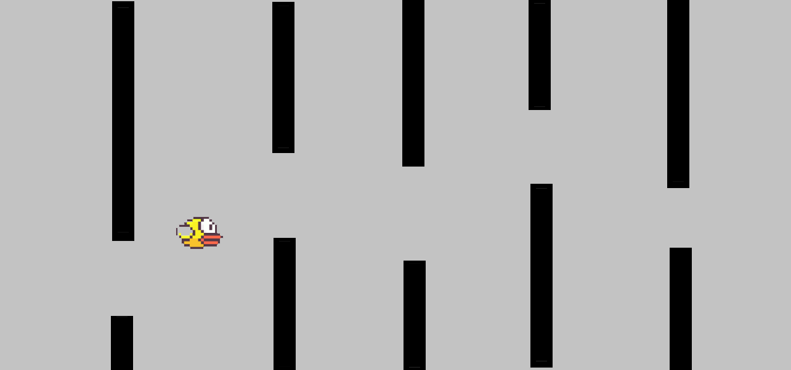

How do you plan to make your game engaging?

There is score needed to achieve to win, unlike the other versions. This score is not easy to accomplish, which engages the gamer to want to finish the game.